**Installation Instructions Document**

1. **Run the following script to create a table in a database**

CREATE TABLE [dbo].[HeatMap](

[Id] [int] IDENTITY(1,1) PRIMARY KEY,

[relativeUrl] [nchar](255) NULL,

[x] [int] NULL,

[y] [int] NULL,

[width] [int] NULL

) ON [PRIMARY]

GO (edited)

1. **Install the Sitecore package**

It will install the following items:

/sitecore/content/Applications/WebEdit/Ribbons/WebEdit/View/Heat Map

/sitecore/content/Applications/WebEdit/Ribbons/WebEdit/View/Heat Map/View heat map

1. **Copy the “heatMapMenu.js” file inside the following folder**

Path: \Website\sitecore\shell\client\Sitecore\ExperienceEditor\Commands

Note: The file is inside the installation folder with the same path as the above.

1. **Copy the following Javascript files into the folder of the site in IIS**

* Js\main.js
* Js\heatmap.min.js

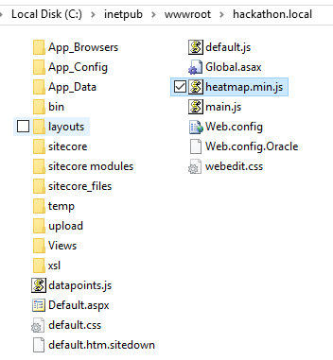

1. **Copy the following dlls into the bin folder of the solution**